Run Performance Monitor
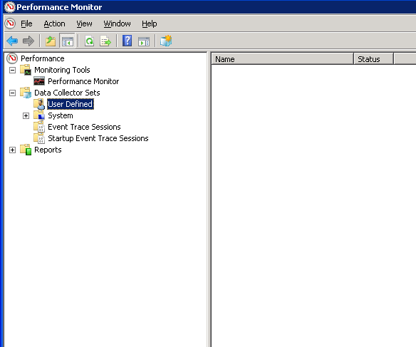
Navigate to Data Collector Sets-User Defined
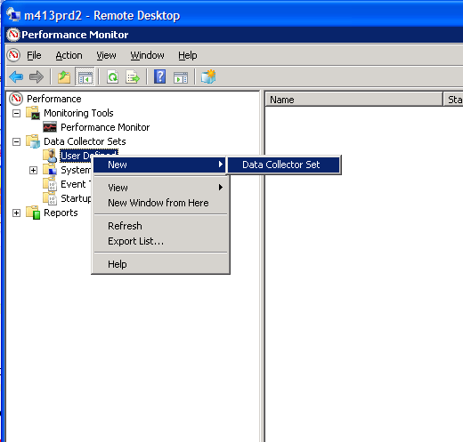
Right-click on User Defined and Select New-Data Collector Set
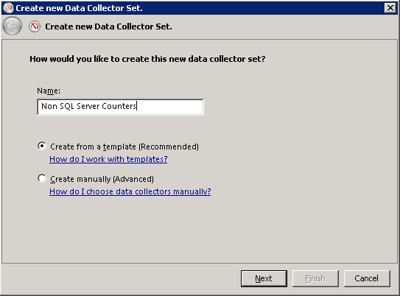
Give the Data Collector Set a name and select Next
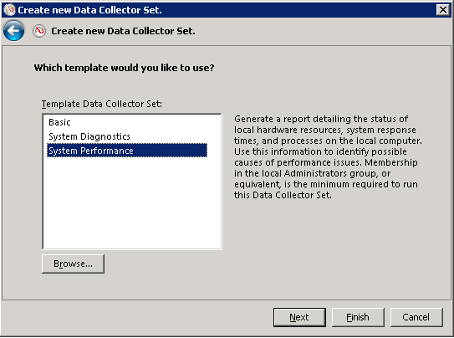
Seelct System Performance and click Browse
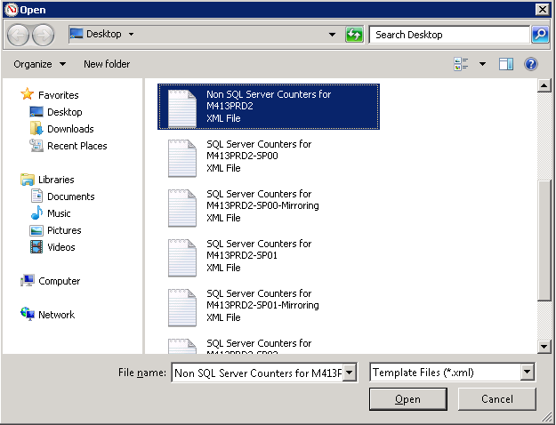
Locate the Template and select Open
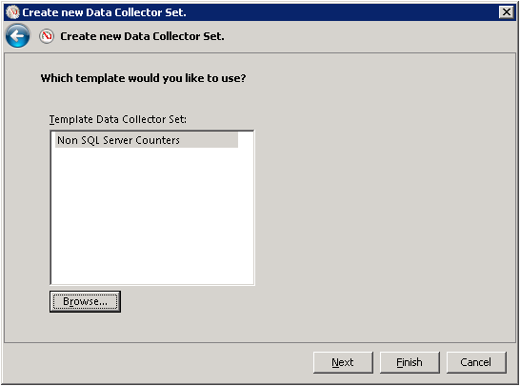
Select Next
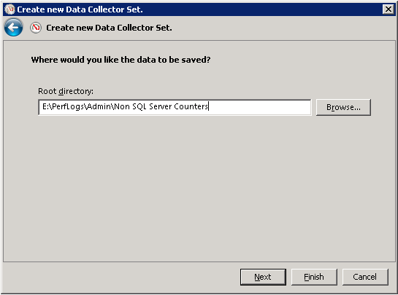
Select a location to send the output and click Next
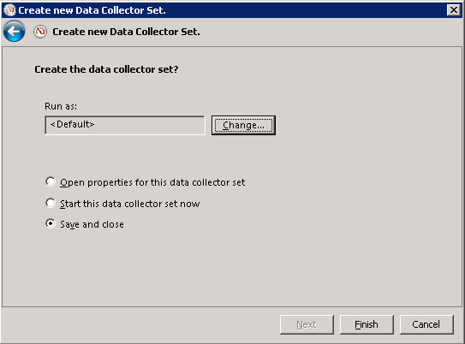
Select Save and Close and click Finish
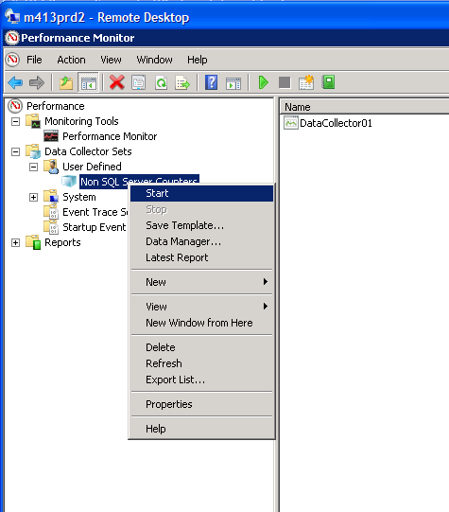
Right-click on the data collector set and select Start to start capturing data
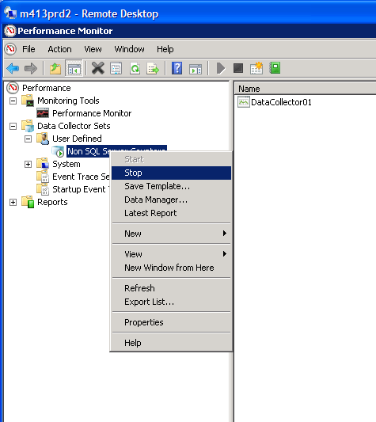
Right-click on the data collector set and select Stop to stop capturing data
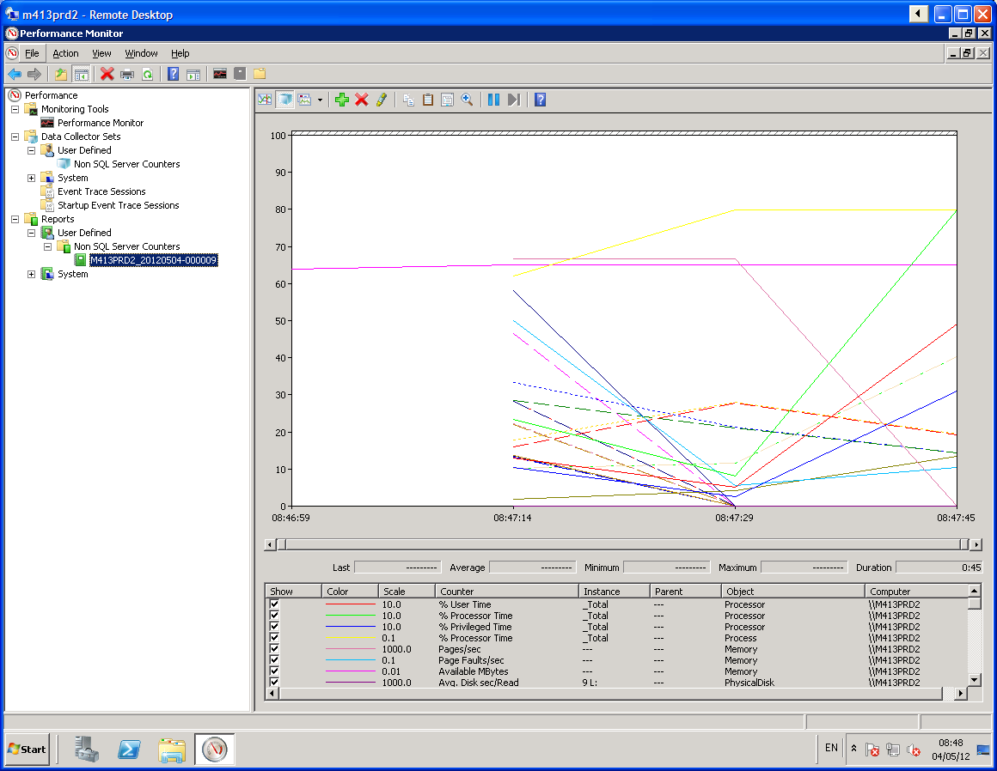
Navigate to Reports-User Defined-<Data Collector Set Name> and select the report listed below to see the data captured

